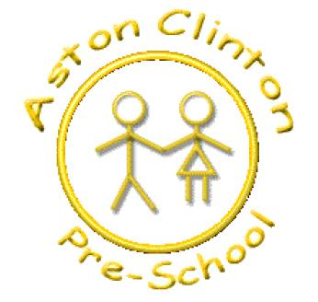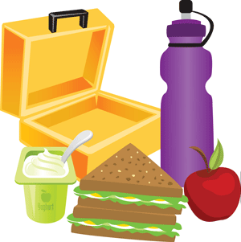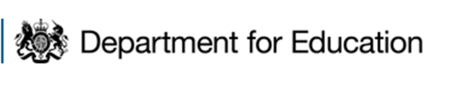

Aston Clinton Pre-school

Lunchbox Guide.

As part of our commitment to healthy eating, we have implemented guidelines for lunches in line with guidance from Department for Education .

It is recommended that a balanced lunchbox contains the following:

* Starchy foods such as breads, rice, potatoes or pasta.
* A source of protein such as meat, fish, eggs, beans etc.
* A dairy item which could include a yoghurt, cheese or a drink of milk.
* Some vegetables or salad plus a portion of fruit.

In line with these recommendations and alongside our local school guide, we ask for the following rules to be observed also:

* A drink must be water, fruit juice or milk (no fizzy please!)
* If children are having grapes, please cut them length ways to avoid choking hazards.
* No chocolate bars or sweets (chocolate lunchbox snacks are allowed!)
* If you would like to give your children crisps, baked crisps are healthier.
* No fried foods.
* We are a nut free setting and therefore no foods may contain nuts.

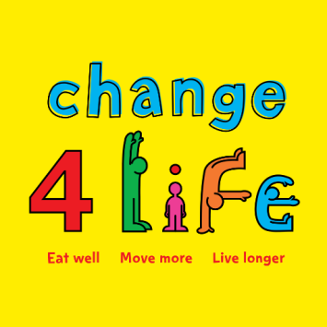

For more information or healthy lunchbox ideas, please visit;

<https://www.nhs.uk/change4life/recipes/healthier-lunchboxes>